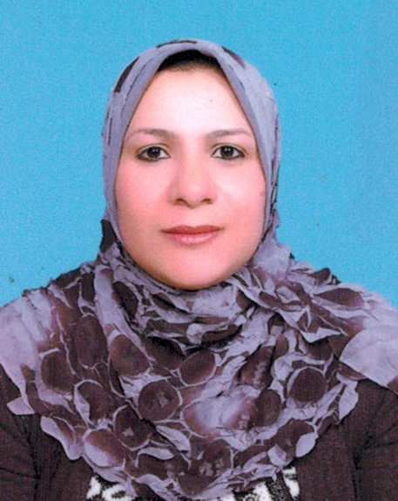
C.V
**********

Name : Sherin Heissun Abd El-Hares Dib
Mobile : 01021362962
E-MAIL : mrhanysabry@yahoo.com

PERSONAL DATA :-

Date of Birth | : 21/8/1983
Gender | : Female
Marital Status | : Married
Nationality | : Egyptian
Religion | : Muslim.

Higher Studies:
Master Degree of Medical Surgical Nursing .
Qualification: - Bachelor of Nursing , 2004 , Menoufia University
General Grad : Excellent with Honors
- Registered in PhD from 2014 .

Working Experiences:
- Clinical Instructor in College of Nursing, Menoufia University from 2005 till now .
Courses:
1- Course in TOEFL on 20 December, 2008 from the American University in Cairo.
2- ICDL Certificate, 2005.
3- BLS Provider 2016 from AHA
4-ACLS provider 2017 from AHA
LANGUAGE SKILLS:-
Arabic: Native Language
English: Very Good Command

